Cataners Final Report

State of Game Features:

Overall the game is nearly 100% finished. We have had great success in providing not only a functioning game, but one that is applicable to the real-world. Our Settlers of Catan features full-networking and ability to join, chat, and play with friends on different computers. Once inside a game, players can roll the dice, obtain resources, and buy all game objects as normal. The only parts of the game that are not the exact same as the original Settlers of Catan are ports, the robber, and development card usage. In our game there are no ports. Players can trade with each other or they can trade to the bank for a 4:1 ratio but we left out ports for time constraints. Also, the robber is not enabled in our game. Rolling a 7 is just a dead roll and nobody gets resources. The last change is our development cards, which do work, but on year of plenty and monopoly, you do not get to choose which cards you would like. These are randomly selected for you to increase the fun and luck of the game. There is also a timer that will auto roll for you and end your turn if you do not play in the set time. Other than that, all game features seem to work as the original to provide an entertaining and rewarding game.

Testing Strategies Employed With Examples:

In our project we used quite a few testing strategies.

* Scripted automated white box unit testing of almost everything in our CatanersShared project.

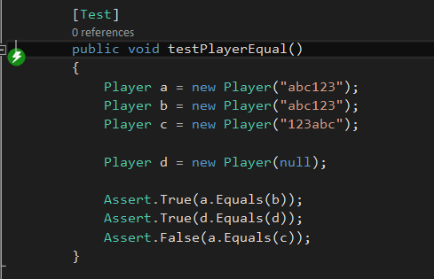

* scripted automated white box integration testing

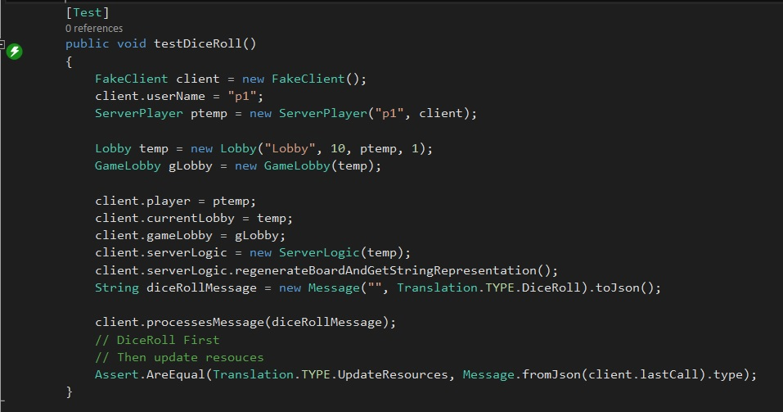

* scripted manual white box integration testing

We logged in, created a lobby, entered the game, and tried clicking two roads with a breakpoint on the buy road function. The game should not allow us to click more than one road.

* exploratory manual white box system testing

We logged in, created a game, entered the game, and played through until the game had ended, looking for bugs and testing difficult methods that require all of the game along the way, such as win conditions or longest road.

* exploratory manual black box acceptance testing

We had other people download out game, sign up, log in, play the game, and tell us if everything seemed to work out okay.

* Mocking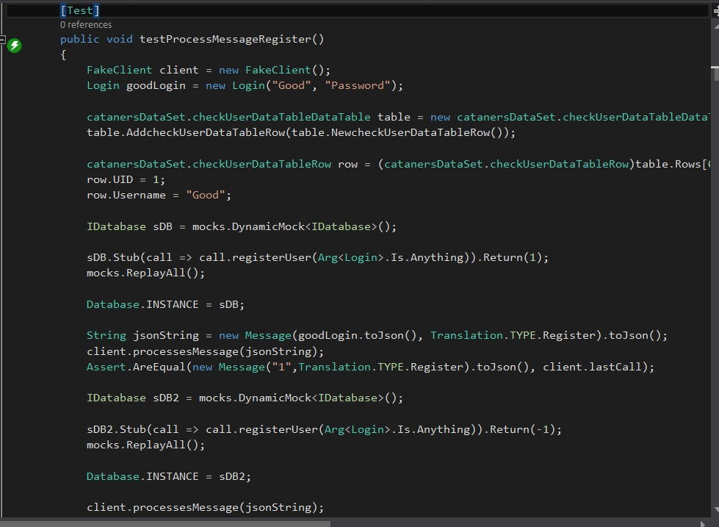

Testing Strategies Not Employed

* Any Exploratory Automated Tests
* Any Automated Acceptance or System testing

Thoroughness of Testing:

Our group did very thorough testing in the parts of our application that could be tested.

|  |  |  |  |  |
| --- | --- | --- | --- | --- |
|  | Statement Coverage | MC/DC Coverage | Cyclomatic Complexity | Maintainability Index |
| Cataners | 64.48% | 77.52% | 72 | 525 |
| CatanersShared | 98.51% | 100% | 87 | 125 |
| CatanersServer | 82.12% | 88.83% | 88 | 368 |